
Chapel, McMurtrie & Bartlett
Chiropractic Orthopedics and Sports Medicine

Howard J. Chapel, D.C., D.A.B.C.O.
Kern McMurtrie, D.C., CCSP.
Rachel Bartlett, D.C., L.Ac., CCSP
Ian McDonald, D.C.

Patient Information
Name ____________________________________________________ Date _______________________________
Address_____________________________________ City ________________________ State _____ Zip ___________
Home # _________________________ Cell # ___________________________ Work # _____________________
E-Mail Address _________________________________________________ Social Security # ____________________
DO YOU SMOKE?
NO YES

IF YES, HOW MUCH ________________

ARE YOU A FORMER SMOKER?
NO YES

ETHNICITY:

NON-HISPANIC OR NON-LATINO
HISPANIC
LATINO

HEIGHT_________ WEIGHT________

RACE: AMERICAN INDIAN
ALASKA NATIVE
ASIAN AFRICAN-AMERICAN
OTHER PACIFIC ISLANDER
WHITE
NATIVE HAWAIIAN

Employer _____________________________________________ Occupation _________________________________
Describe Daily Duties _______________________________________________________________________________
Hobbies / Recreational Sports ________________________________________________________________________
Date Of Birth ______________________ Age _____________ Marital Status [Married] [Widowed] [Single] [Divorced]
Spouses Name ______________________________ Employed By ____________________________________________
Children (Names/Ages) _____________________________________________________________________________
Primary Insurance Company __________________________________________ ID# ____________________________
Secondary Insurance Company ________________________________________ ID # ____________________________
Patient History
What is your major complaint? _______________________________________________________________________
Date Of Injury ___________________ How did the injury occur? ____________________________________________ List other doctor(s)/therapists seen for this condition? _____________________________________________________
What activities make the problem worse? ________________________________________________________________
What activities make the problem better? ________________________________________________________________
Is this condition getting better or worse? _______________________________________________________________
Is the pain constant or does it come and go? _____________________________________________________________
Is this condition related to an automobile or on-the-job injury? _____________________________________
Current Medications (over the counter & prescription)
________________________________________________________________________________________________
Family Physician ___________________ Females: Are you pregnant, or a chance you might be pregnant? yes no
How were you referred to our office? __________________________________________________________________

MEDICAL HISTORY:

Please indicate (1) if previously had, OR (2) if presently have for conditions listed below:

Musculo-Skeletal: Gastro-Intestinal: Urinary:
__low back pain __poor appetite __bladder trouble
__pain between shoulders __excessive hunger __excessive urine
__neck problems __difficulty swallowing __painful urination
__arm problems __nausea __discolored urine
__leg problems __vomiting food
__painful joints __vomiting blood Female
__stiff joints __abdominal pain __vaginal bleeding
__sore muscles __diarrhea __vaginal discharge
__weak muscles __constipation __breast pain
__broken bones __black stool __breast augmentation
__bloody stool __lumps in breast
Nervous System __hemorrhoids
__numbness __liver trouble Other:
__loss of feeling __gall bladder problems ________________
__paralysis __weight trouble ________________
__dizziness
__fainting Using the symbols given below, mark the areas on
__headaches your body where you feel the described sensations,
__muscle jerking include all affected areas:
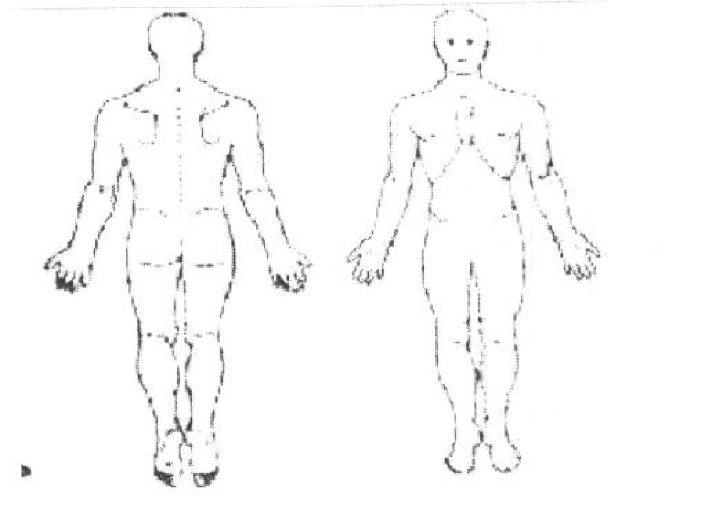
__convulsions
__forgetfulness
__confusion
__depression

Cardiovascular-Respiratory
__chest pain
__difficult breathing
__persistent cough
__coughing blood
__rapid heartbeat
__blood pressure problems Numbness Pins & Needles Burning
__heart problems ----------- 000000000000000 XXXXX
__lung problems Aching Stabbing
******* //////////////
Please List all Hospitalizations and / or Surgeries:________________________________

________________________________________________________________________

________________________________________________________________________

Signature __________________________________________ Date _________________
(If patient is a minor, signature of parent or guardian)

Payment Policies

- Patient Portions / Payments:
  - Are collected after EACH visit.
  - We accept: Cash, Personal Check, Visa and Mastercard
- Health Insurance:
  - We DO accept most insurance plans, and most insurance plans DO cover Chiropractic care. It is YOUR responsibility to give to the correct information about your insurance company, and is YOUR responsibility to follow the rules outlined by your insurance company. E.g. referrals
  - We will call your insurance company to verify your chiropractic coverage. We will collect any co-payment and/or deductible amounts quoted by your insurance at the time services are rendered. If there are any discrepancies when the claims are processed, you may be responsible for any additional monies. We advise you to contact your insurance company to verify your benefits. If you are told different benefits, please advise our office.
  - We will submit all claims for services rendered in our office to your insurance company
  - We feel all procedures performed in our office are medically necessary. However, some insurance companies in an attempt to save cost, will consider some services as “non-covered”, or “not medically necessary.” Any services, which are denied, will be your responsibility.
- Auto Accidents:
  - The patient MUST select which entity (personal health insurance, personal auto med pay, party at fault auto insurance) will be responsible for reimbursement of services rendered by the conclusion of the first visit. (Please direct questions regarding the selection to the Doctors during your consultation)
  - A signed lien is a REQUIREMENT for treatment in this office.
  - If you are dealing with an auto insurance company or involved in a lawsuit that affects the payment of the services rendered, please be advised that payment is due no later then 90 days of discharge from our office, whether or not your case has settled. It is YOUR responsibility to stay on top of your case with the party at fault auto insurance, and/or your attorney.
- Medicare:
  - We DO NOT accept Medicare assignment. Medicare members must pay in full at the time services are rendered. We will submit claims to Medicare, and any reimbursement they make will be sent directly to you.
  - It is YOUR responsibility to make our staff aware if you have a secondary insurance and if you are set up for “cross-over.”
- Overdue Accounts
  - Any patient portion unpaid after 90 days from the date of service will be subject to an 18% charge.

I have read the above terms and hereby assume full responsibility.

__________________________________________ _________________
Patient / Responsible Party Date

Informed Consent to Chiropractic Treatment

Chiropractic treatment, including spinal adjust, has been the subject of government reports and multi-disciplinary studies conducted over many years and had been demonstrated to be effective treatment for many neck and back conditions involving pain, numbness, muscle spasm, loss of mobility, headaches and other similar symptoms. Chiropractic care contributes to your overall well being. The risk of injuries or complications from Chiropractic treatment is substantially lower than that associated with many medical or other treatments, medications and procedures given for the same symptoms.

Doctors of Chiropractic who use manual therapy techniques are required to advise patients that there are or may be some risks associated with such treatment. In particular you should note:

- While rare, some patients may experience short term aggravation of symptoms, rib fractures or muscle and ligament strains or sprains as a result of manual therapy techniques.

- There are reported cases of cerebral vascular accident associated with many common neck movements. Present medical and scientific evidence does not establish a definite cause and effect relationship between upper cervical spine adjustment and the occurrence of stroke. Furthermore, the apparent association is noted very infrequently and estimated at one per one million. However, you are being warned of this possible association because stroke sometimes causes serious neurological impairment, and may on rare occasion result in injuries including paralysis. The possibility of such injuries resulting from upper cervical spinal adjustments is extremely remote.

- There are rare reported cases of aggravation of existing disc conditions following cervical and lumbar spinal adjustment although no scientific study has even demonstrated such injuries are causes, or may be caused by spinal adjustments or Chiropractic treatment.

I acknowledge that if I have any questions regarding the nature and purpose of my Chiropractic treatment in general and my treatment in particular (including spinal adjustment) as well as the content of the consent I will ask my Chiropractor in advance.

I consent to the Chiropractic treatments offered or recommended to me by my Chiropractor, including spinal adjustment. I intend this consent to apply to all my present and future Chiropractic care.

Dated this _______________________ day of _______________________, 20______________
(day) (month)

_______________________________ ________________________________
Patient Signature (or Legal Guardian) Signature of Witness

_______________________________ ________________________________
Patient Name Printed Witness Name Printed

Personal Medical Information Consent Form

The Health Insurance Portability Accountability Act of 1996 (HIPAA) requires that we receive your permission before we use the personal information in your medical records for any reason.

This consent form gives us permission to use your Protected Health Information (PHI) to carry out treatment, receive and/or as part of health care operations of our practice.

HIPAA also requires us to have a written notice of our privacy policy describing how medical information about you may be used and disclosed. If you so desire, this written notice is available at the front desk for you to read.

HIPAA gives the patient a right to add restrictions to the release of PHI. We as an office do not have to agree to these restrictions, but if we do they are legally binding.

You have the right to revoke, in writing, this consent form at any time, although any services performed prior to the revocation of this consent are covered by this consent.

If you have any objections to this form, please ask to speak with our HIPAA Compliance Officer.

Patient Signature: _____________________________ Date:__________

Right to Revise Privacy Practices: As permitted by law, Chapel McMurtrie and Bartlett Chiropractic Orthopedics reserves the right to amend or modify our privacy policies and practices. A change in our office polices and practices may be required by changes in federal and state laws and regulations. Upon receipt, we will provide you with the most recent notice at your next office visit. The revised policies and practices will be applied to all protected health information we maintain.

Doctor/Staff Signature: _________________________ Date: __________

